* 1. Shell- UNIX command processor
  2. Program- a set of coded instructions contained in a file
  3. Process- what you get whenever a computer runs a program
  4. Option- modify what the command does
  5. Argument- anything that follows the command name
  6. Standard input- the file where the program normally looks for input
  7. Standard output- the file where the program sends output
  8. Grave accent- backquotes used to enclose commands that you want the shell to run
  9. Redirection- redirect the output or input so the data is sent somewhere else
  10. Pipe- connects the output from one utility to the input of another
  11. Tee- save the output from a command in a file and pipe the output to another command
  12. Filter- takes a stream of data from its standard input, transforms the data in some way, and sends the results to the standard output
  13. Metacharacter- wildcards
  14. Wildcard- abbreviate file names
  15. Quote- cancels the special meaning of characters in a string
  16. Background process- a process that runs unattended in the background
  17. Foreground process- a process running in the foreground
  18. Process id number- a number assigned to every process running in the background
  19. PID- process identification number
  20. Job number- the number in brackets
  21. Job control- makes it easier to manage background processes

1. 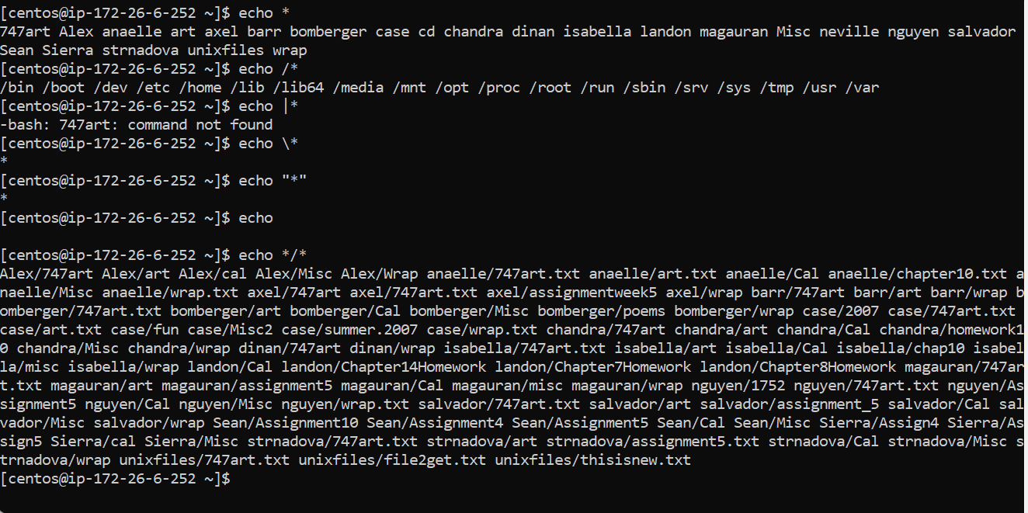
   1. Echo \*- see above
   2. Echo /\*- see above
   3. Echo \\*- would return star as the backslash cancels it
   4. Echo “\*”- would return star as the quotes cancel the meaning of \*
   5. Echo- would return anything after as long as their are no special characters
   6. Echo \*/\*- see above
   7. Rm - would remove all file
2. Cat \*ing
3. Ls \*[Xx]\*
4. Cat \*o\*
5. Cat b\*ack\*